FastAlyze Project – Is it worth ?

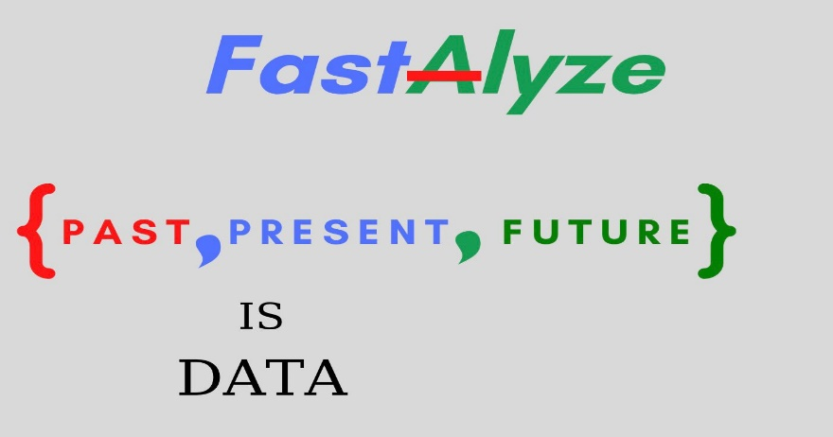

You are probably asking … What the hack is FastAlyze ? … Personal project written 100% in python ? … This man is probably crazy and probably escaped from the asylum of mental problems.

I’m sure that some of you consider that . I don’t care what somebody or someone thinks about me … it is very important to truly believe in yourself and your power … that’s the only way drawn, straight to success.

Anyway … with no more shit talking … all of us … sometime in life wondered to do something with themselves , to be involved in particular circles … respectively to achive multipe things or get somewhere . What I mean is that , all o us has , I think so , has this special ability called … “ambition”. The worst problem , is only a few has already activated it .

In my case , the ambition had a special place in my mind … because everywhere I was going to … summer camps , schools , particular courses , holidays , visiting relatives , etc. … At the end of all these moments … people where telling me : “Andrew … you are very ambitious!” and I asked myself “What’s the reason or what have convinced/concerned all these people to appreciate me and my behaviour ?” … From nowhere , on a summer day , from the darkest bottom of my brain … my inside voice said : “You are ambitious!” … and from that moment I realized that is the reason why I am making part of a prestigious college , that’s the reason I have only 3 friends( few but more than gold ) , that’s why I’m studying informatics in high school right now , that’s why I’ve started this website , that’s the main reason I’ve started this project ( I enjoy entering or starting new things , but things that inspire and which probably have no end – that are the things which matter ).

As I was saying , FastAlyze is a part of me , represents my ambition and reflects me as open-hearted and thirsty of knowledge .

Ok … but leaving the philosophical part aside , what will be actually Fastalyze ?

FastAlyze is a open-source( that I would like to be ) platform for editing and visualize data dynamically with the help of matplotlib charts . It is all content written from 0 to hero in the “language of future” (python , of course ! – all against it will see they were mistaken) with some converting data & files format tools that I am taking from multiple people.

Now , I’m gonna show you some picture with the project for who are interested in it … and wanna contribute … CONTACT ME ! Thx !!!

For who that only wanted to visualize my post … I wish them a tone of luck … an don’t forget … Perseverance is the key to success !!!

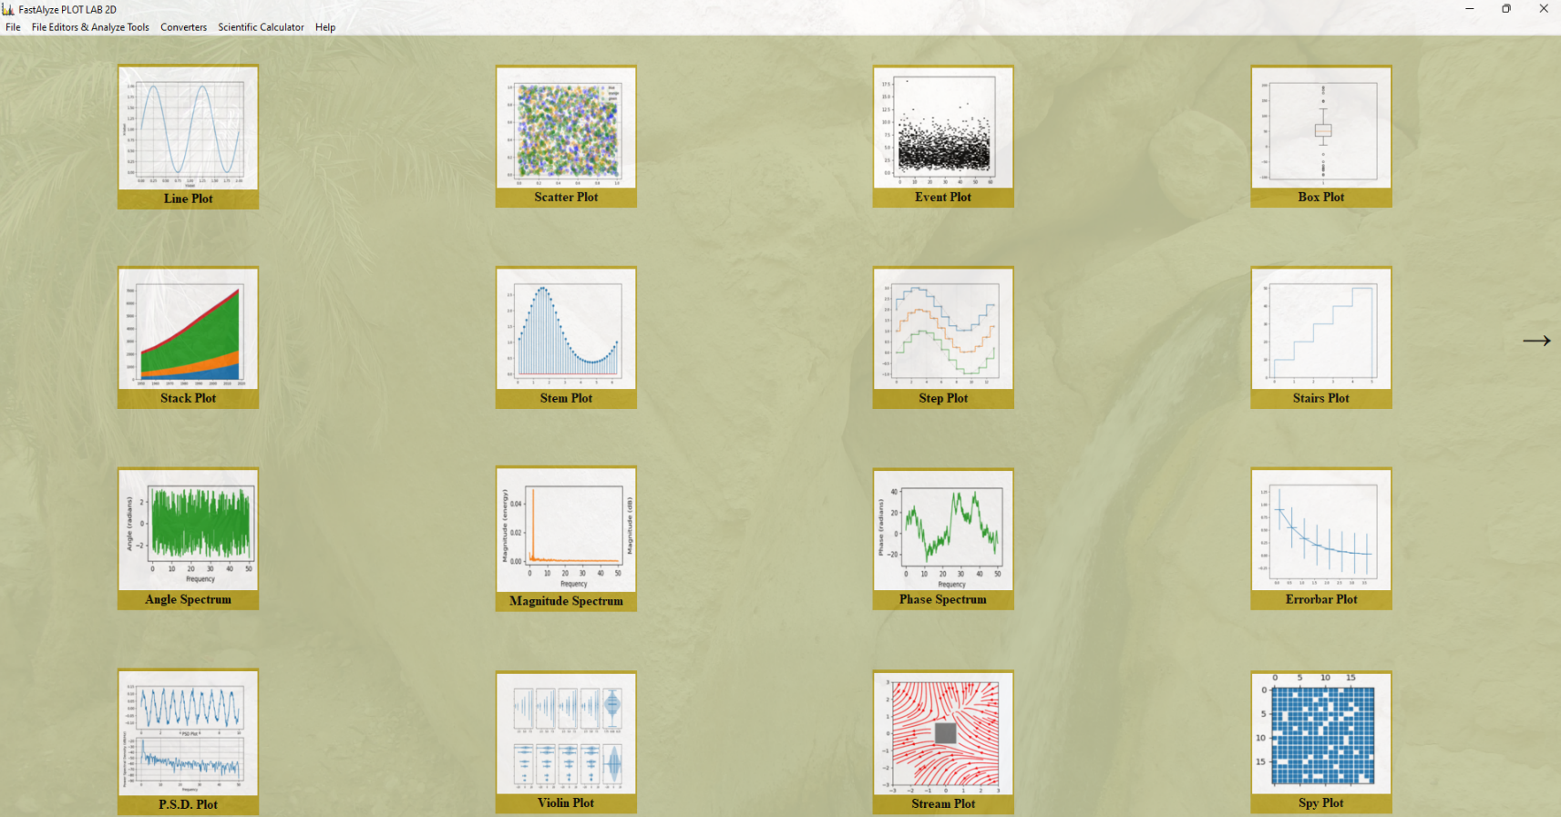

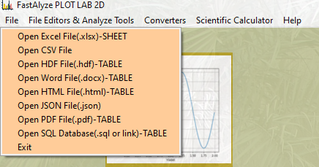

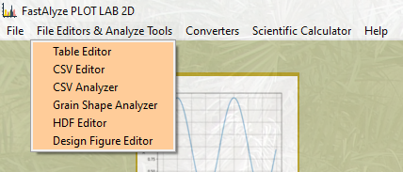

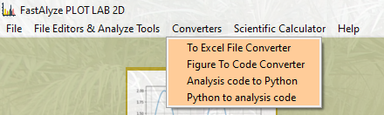

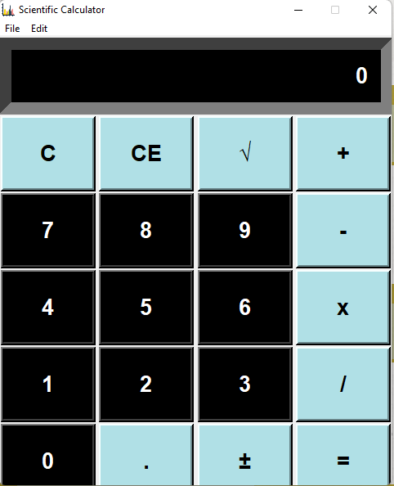

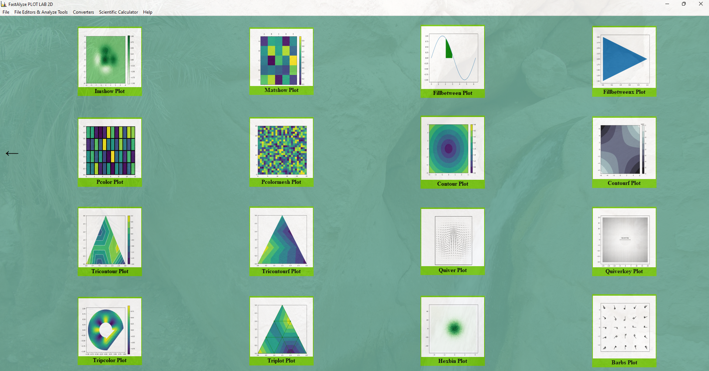

I’ll come back with another article on this theme !!!

[**BACK TO BLOG**](blog.html)